Walkthrough - SlickOS

Contents

Contents 1

Host Discovery 2

2

Nmap 2

Firefox Proxy 3

Nikto 3

Viewing Website 3

3

Exploitation 4

Escalation 4

Upgrade Shell 4

Finding Binaries 5

Web Directory 5

Sudo -l 6

Flag 6

# Host Discovery

# 

**Kali**: 192.168.56.101

**Victim**: 192.168.56.144

# Nmap





Looking here you can see that squid proxy is being used.



# Firefox Proxy

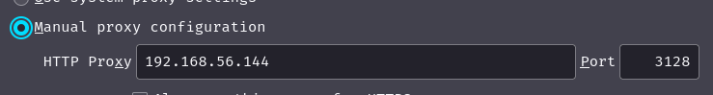

I added the following configuration to the network settings on my firefox browser.

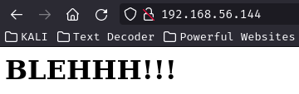

This is what the website shows, if your proxy is working.

# Nikto

This scan contains the squid proxy port. The scan results in a massive output including robots.txt

Robots file contains the *wolfcms* directory.

# Viewing Website

# 

Looking at the source code for the *wolfcms* you will see a format where there is a question mark before the url. Example: /wolfcms/?/admin/login

I tried the default credentials admin:admin and I was able to login.



# Exploitation

Now I have access to the dashboard I can go to the files tab and insert my own php file which will create a reverse shell.

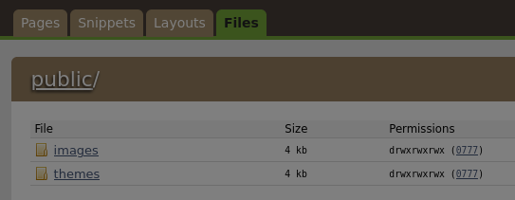

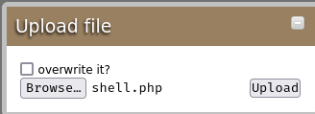

This should upload in the public directory of wolfcms.



# Escalation

## Upgrade Shell



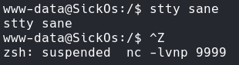

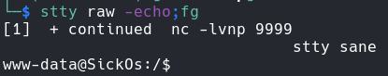

Now you have a proper shell with tab completion.

## Finding Binaries

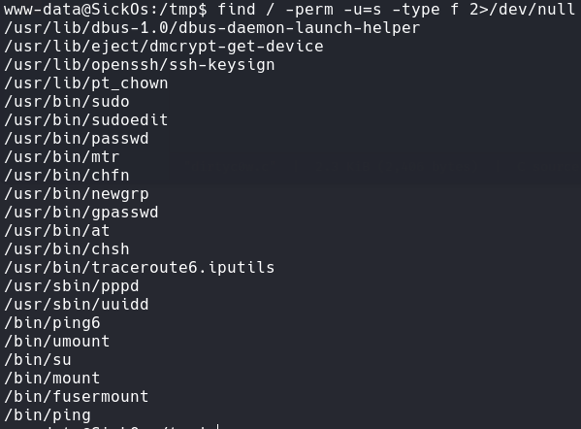

# Web Directory



Connect.py is a database file from first appearance.

It contains the text that says I try to connect things very frequently.

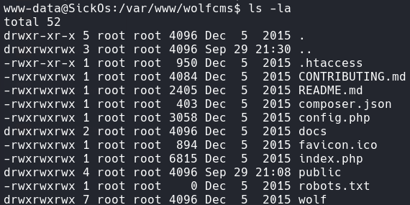

The config.php is interesting. I will cat the file to view the contents.

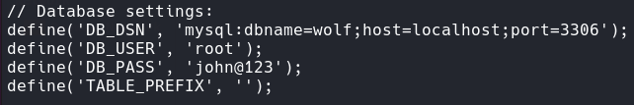



**Credentials** – sickos:john@123

## Sudo -l

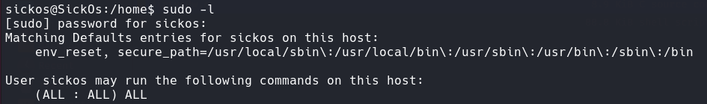I noticed I can run all commands as sudo, so that means I can simply write: sudo /bin/bash



# Flag

It is located in the root directory.



